**Java Batch Installation Document**

Click on start menu > search Company portal > open.

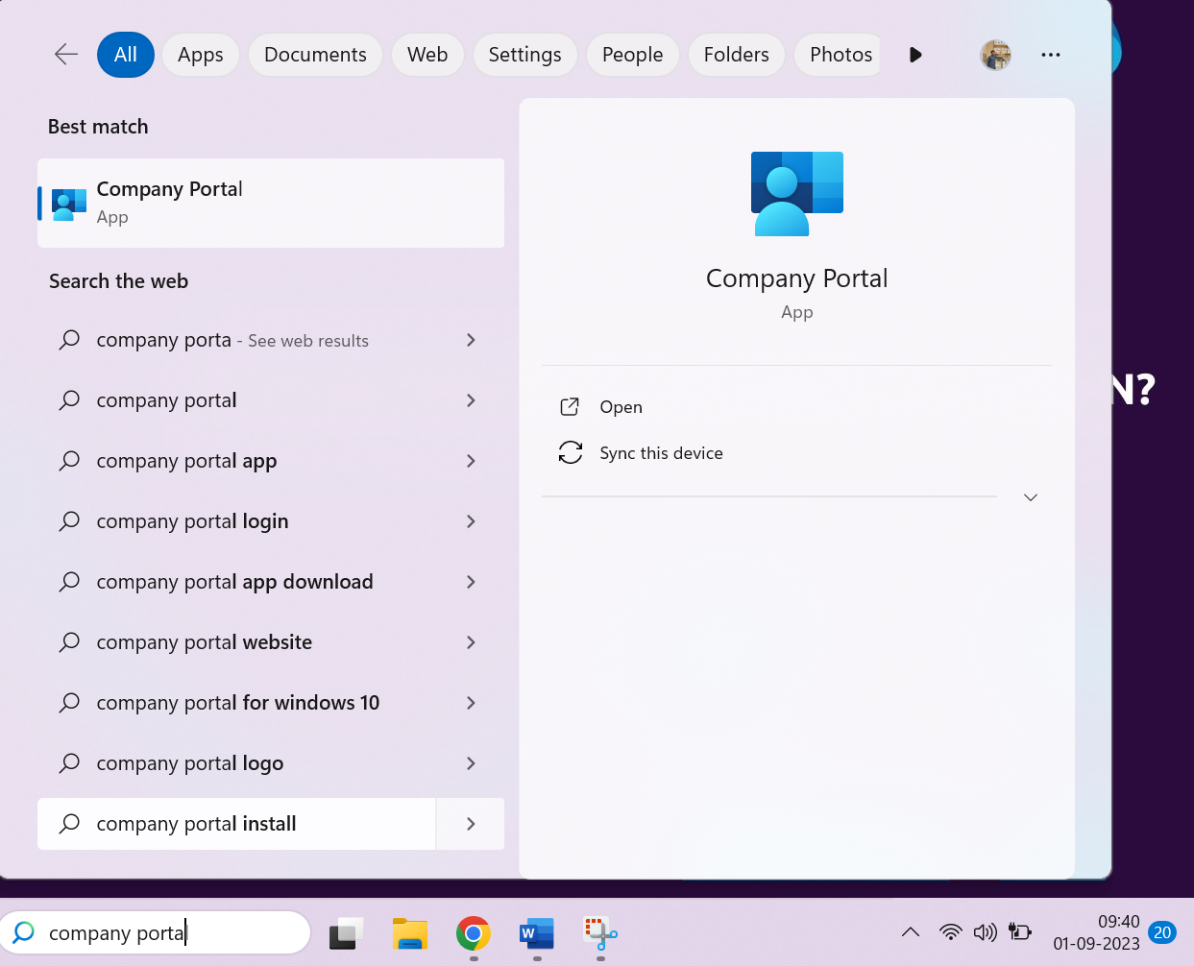

Click on Apps and scroll down

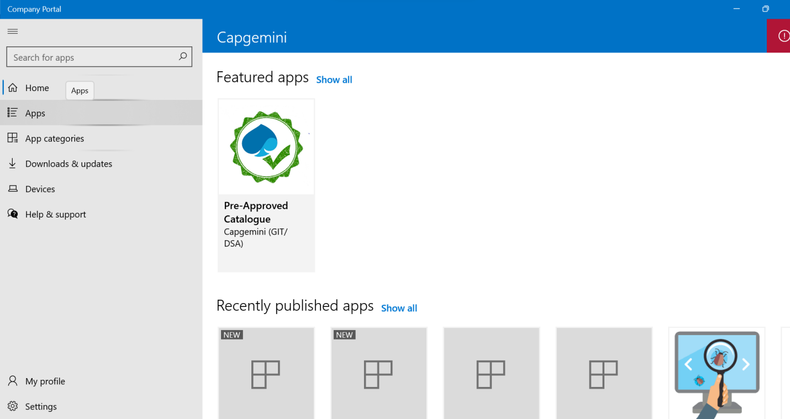

Click on Lnd_Automation_JEE_v10_EN.

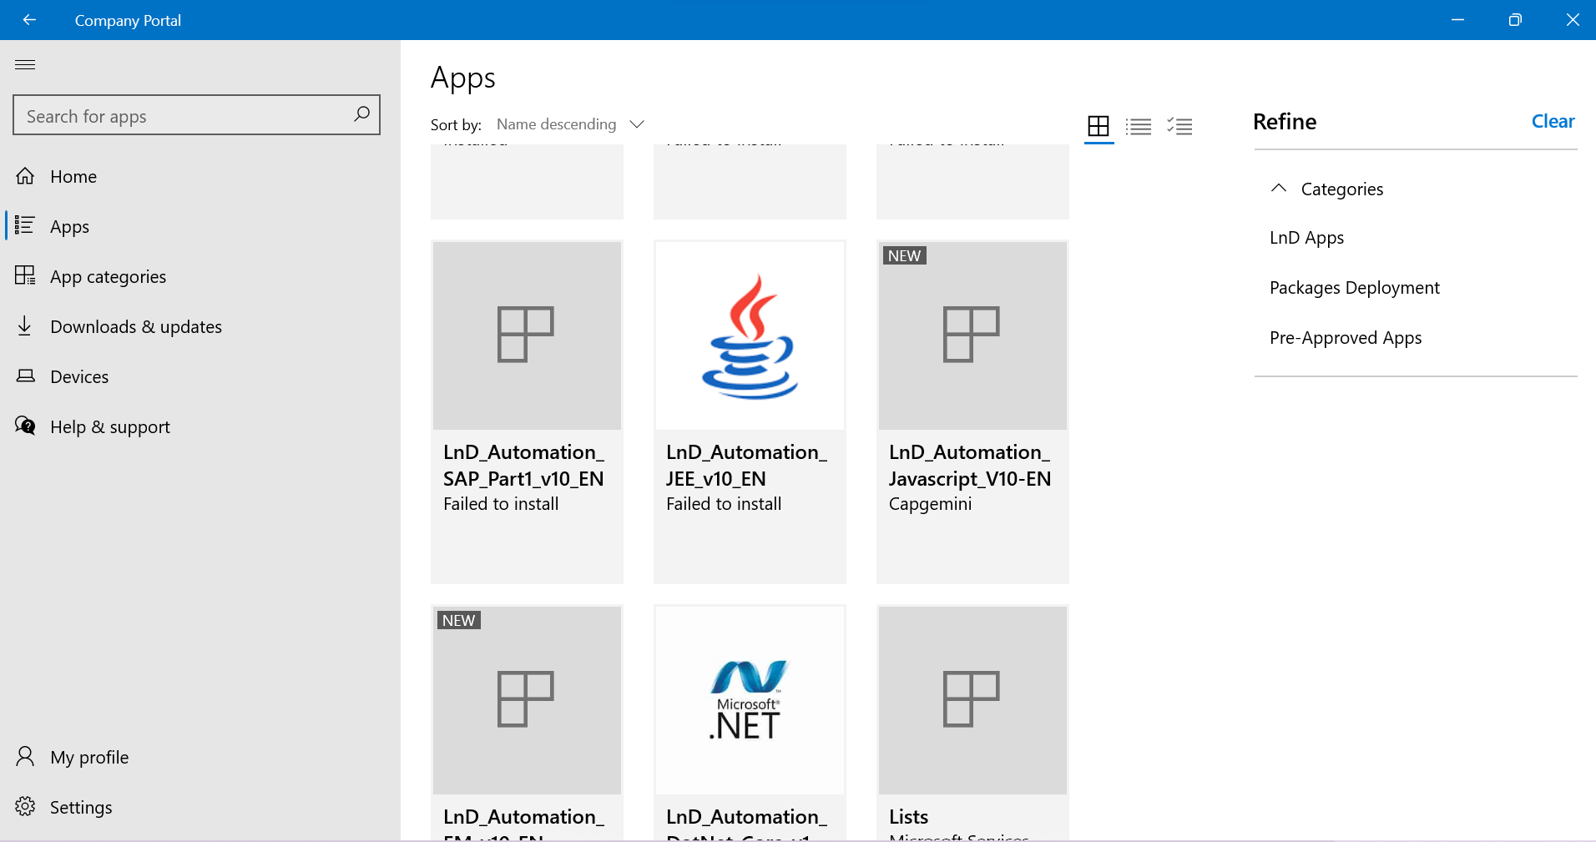

Click on Install

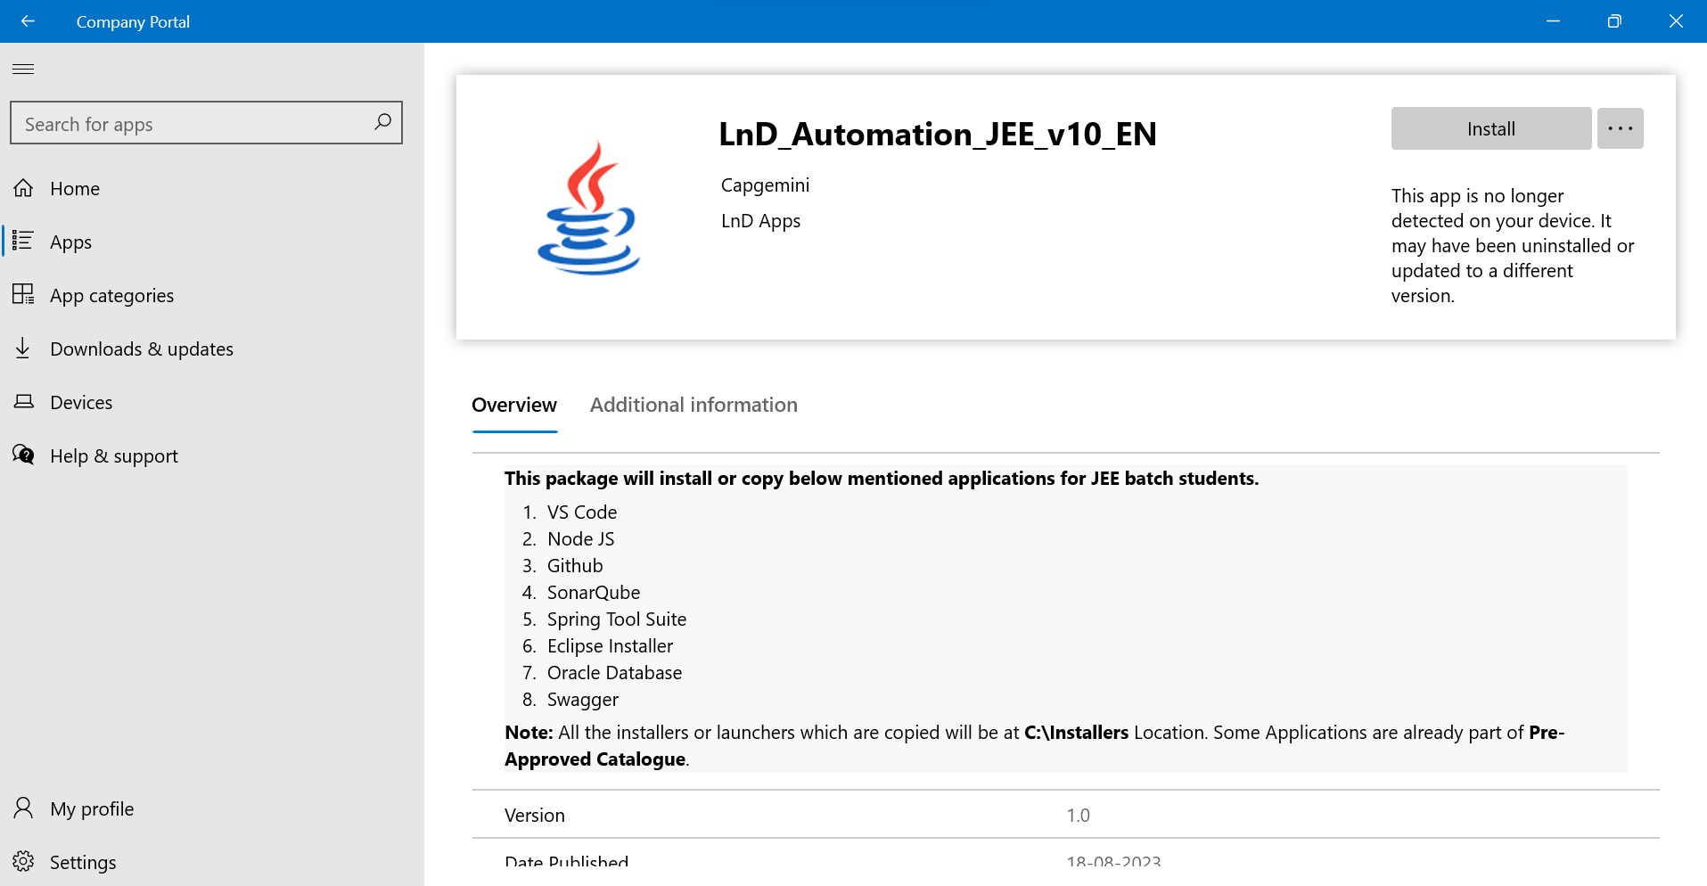

Once installation starts you will get below window

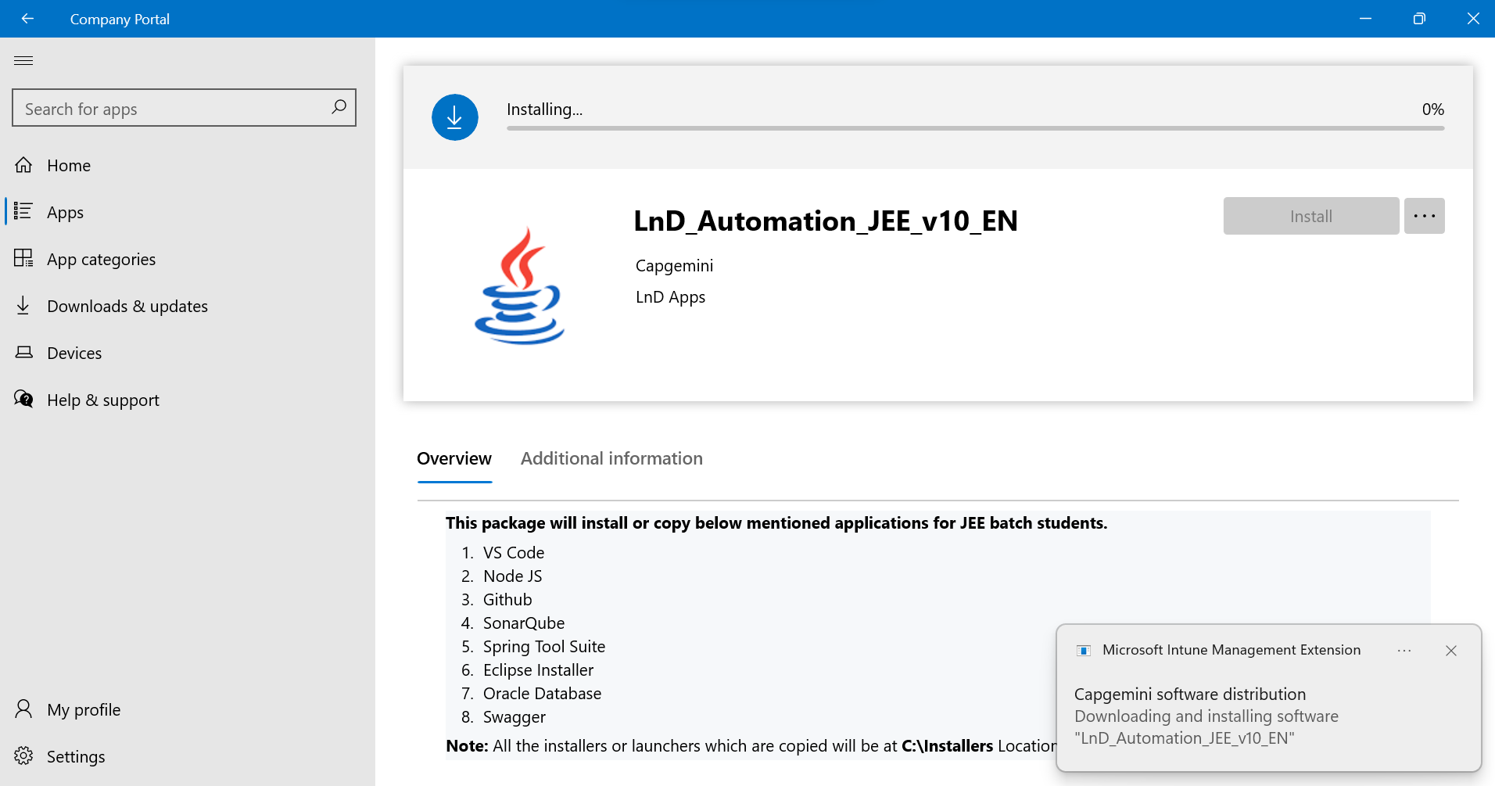

You will get below pop-up After 100% installation completed.(wait for 2 min)

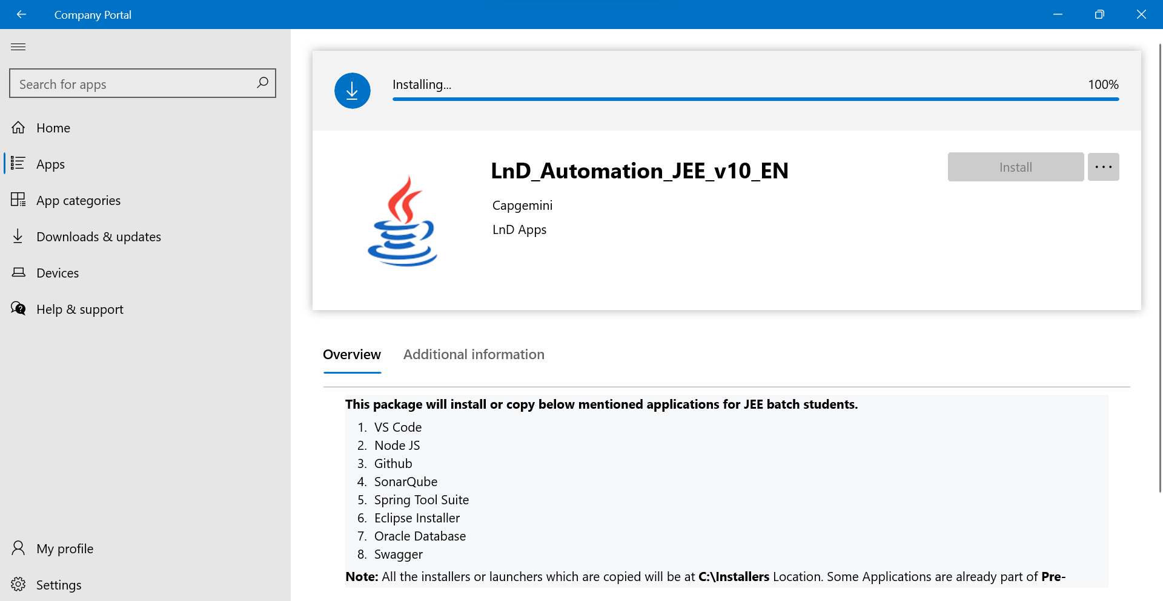

Packages will get executes one-by-one.

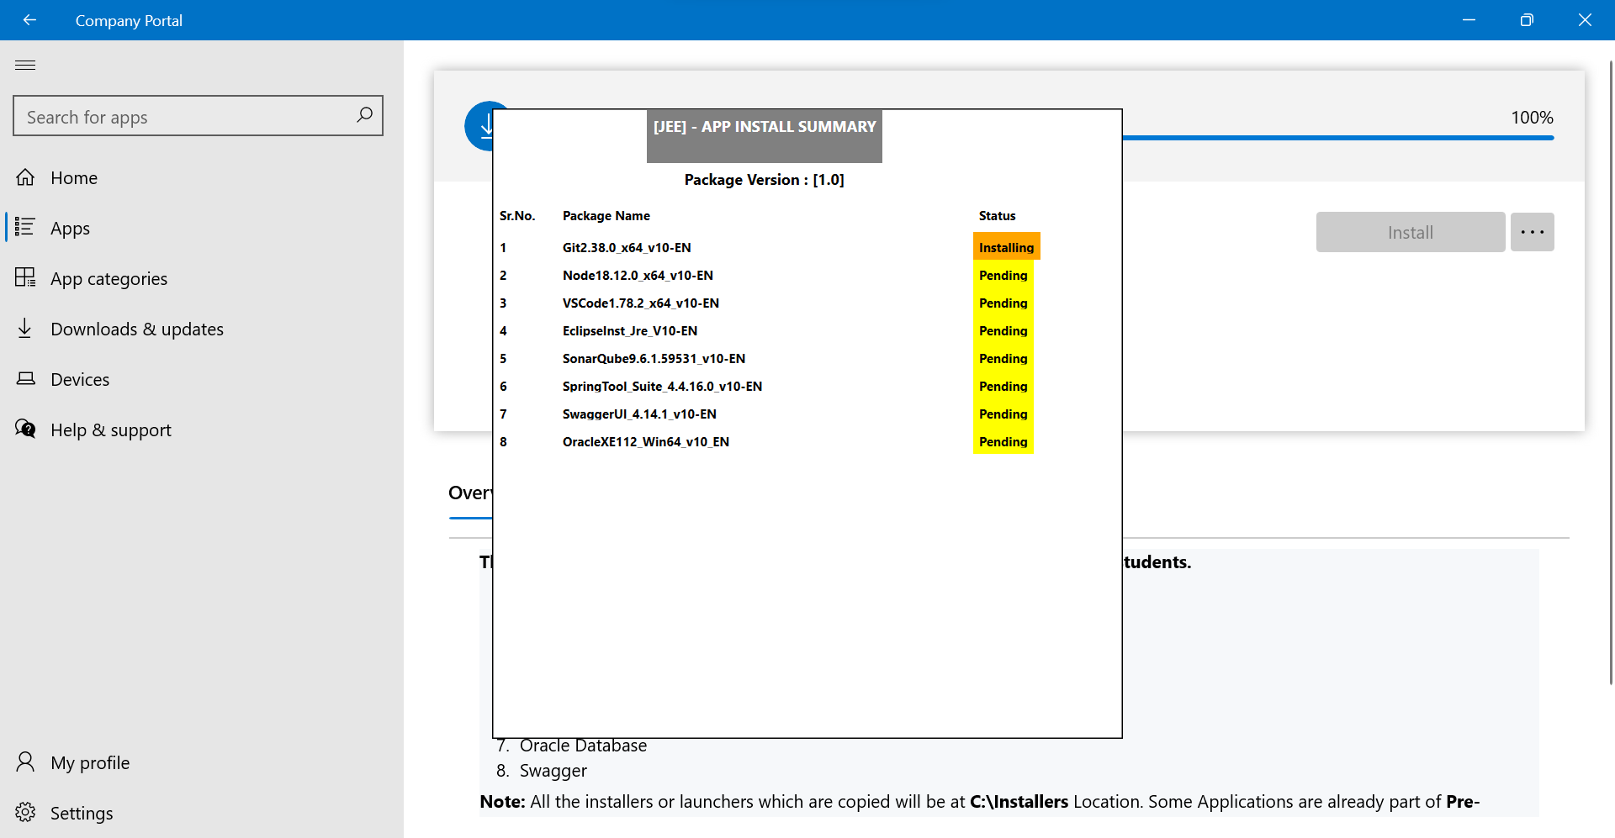

Once Installation of Packages done the below pop-up will appear

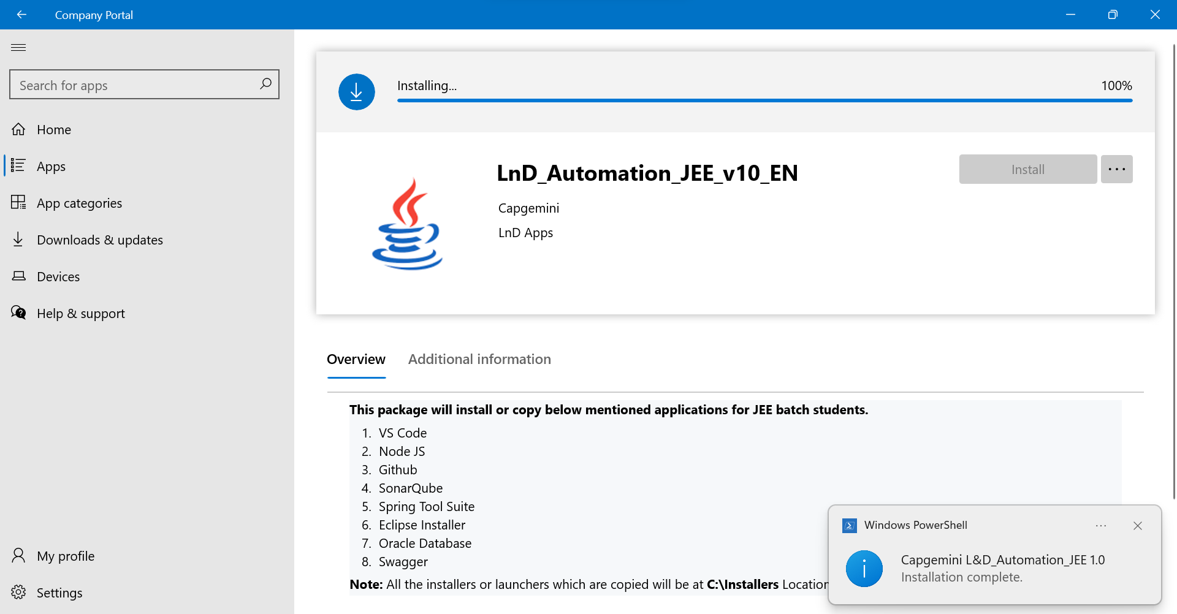

After Installation below pop-up will appear. Close it

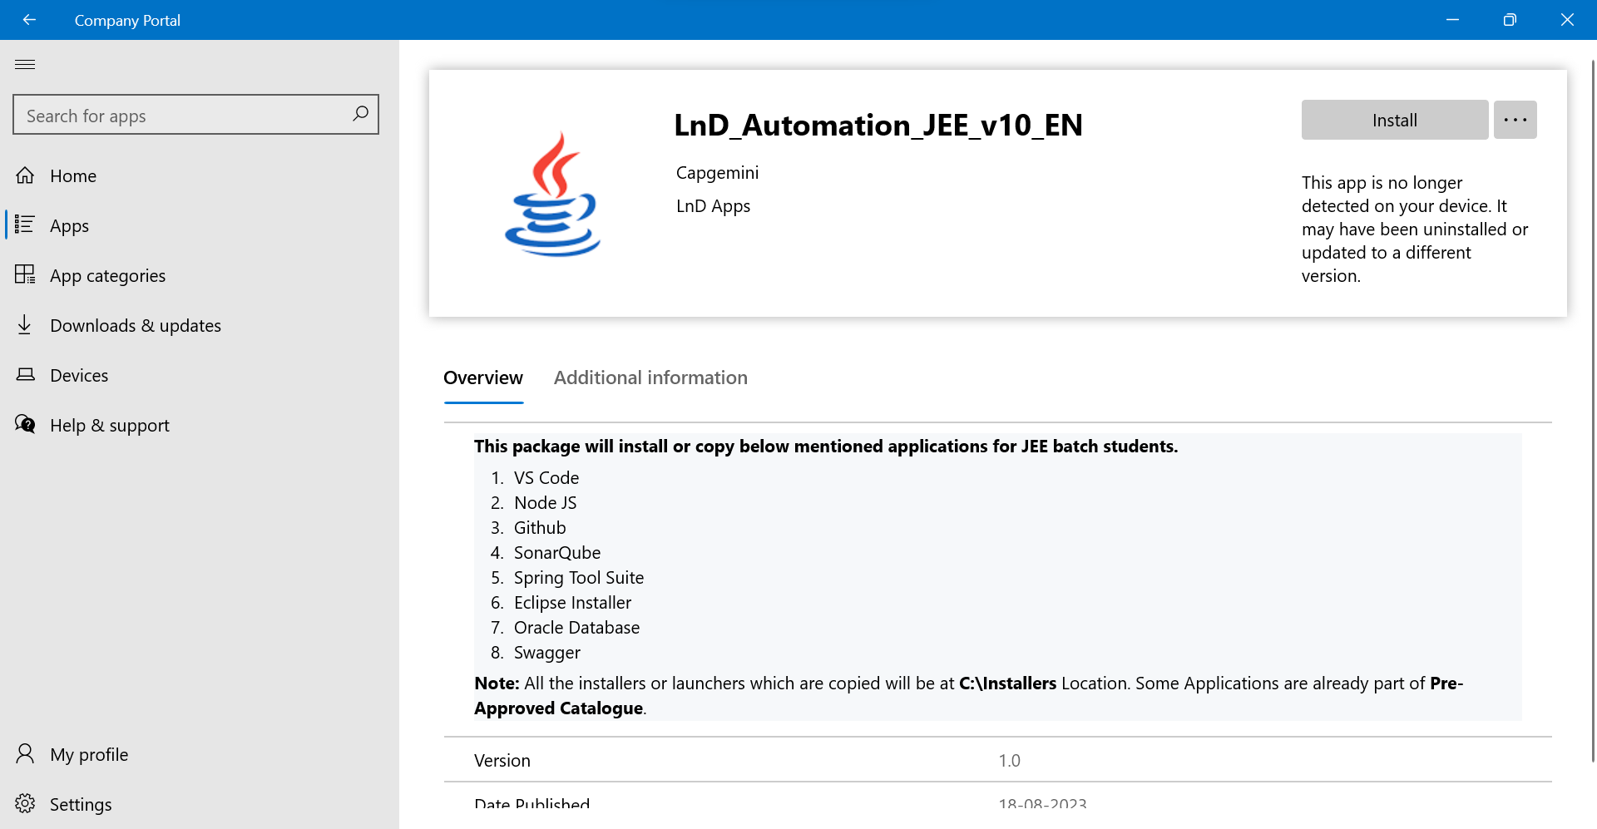

For non installer files you can see in below location.

Click on This PC



Click on System (C:)

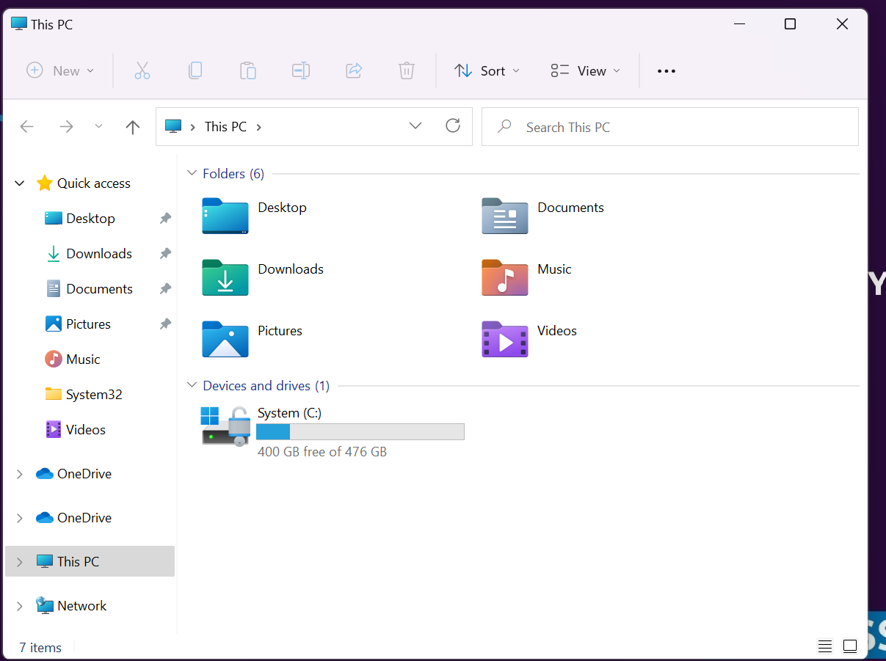

Click on installers folder!

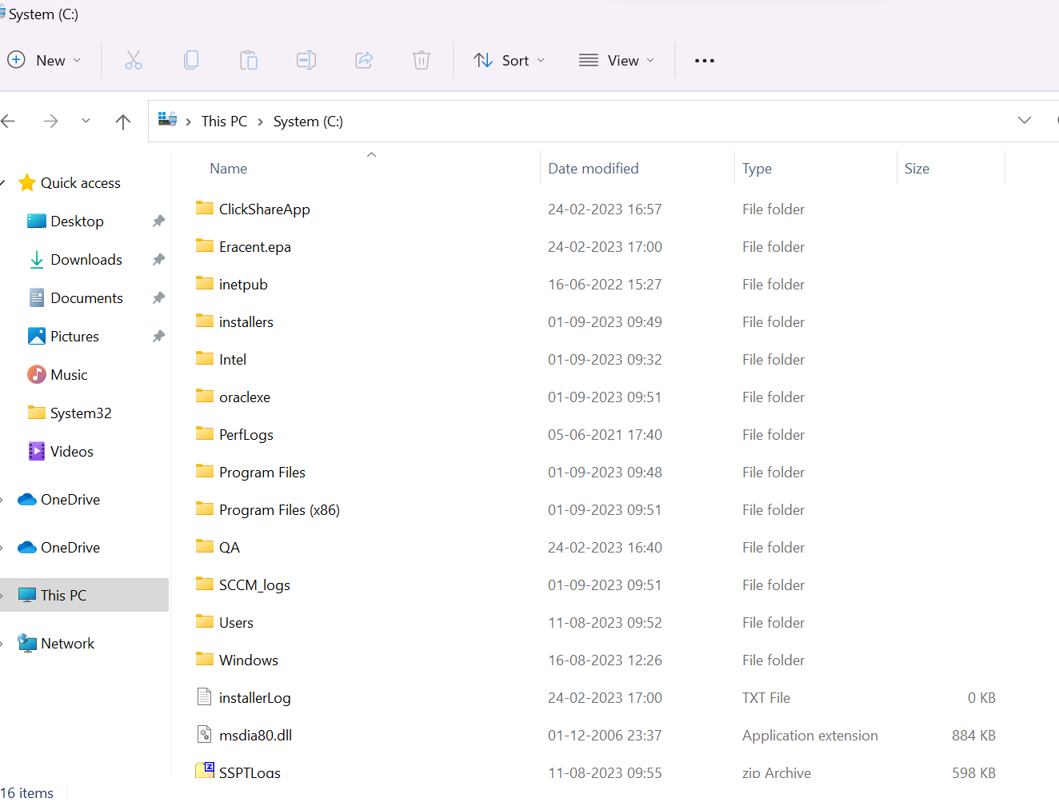

Click on LandD Folder

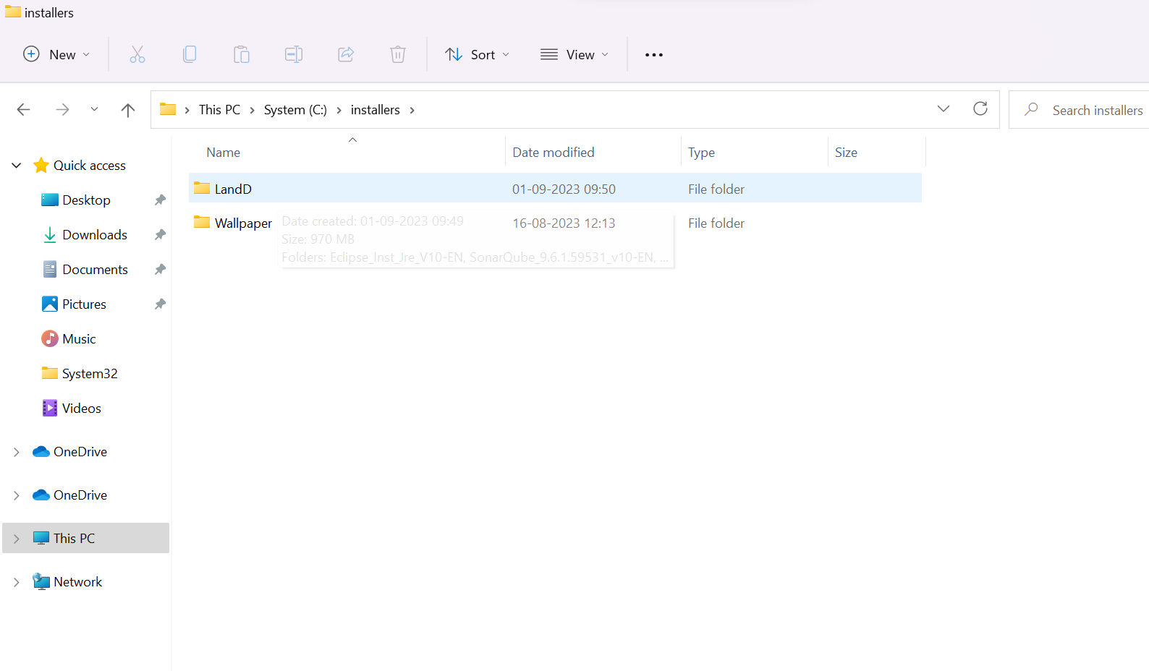

Click on Spring_Tool_Suite_4.4.16.0_v10-EN

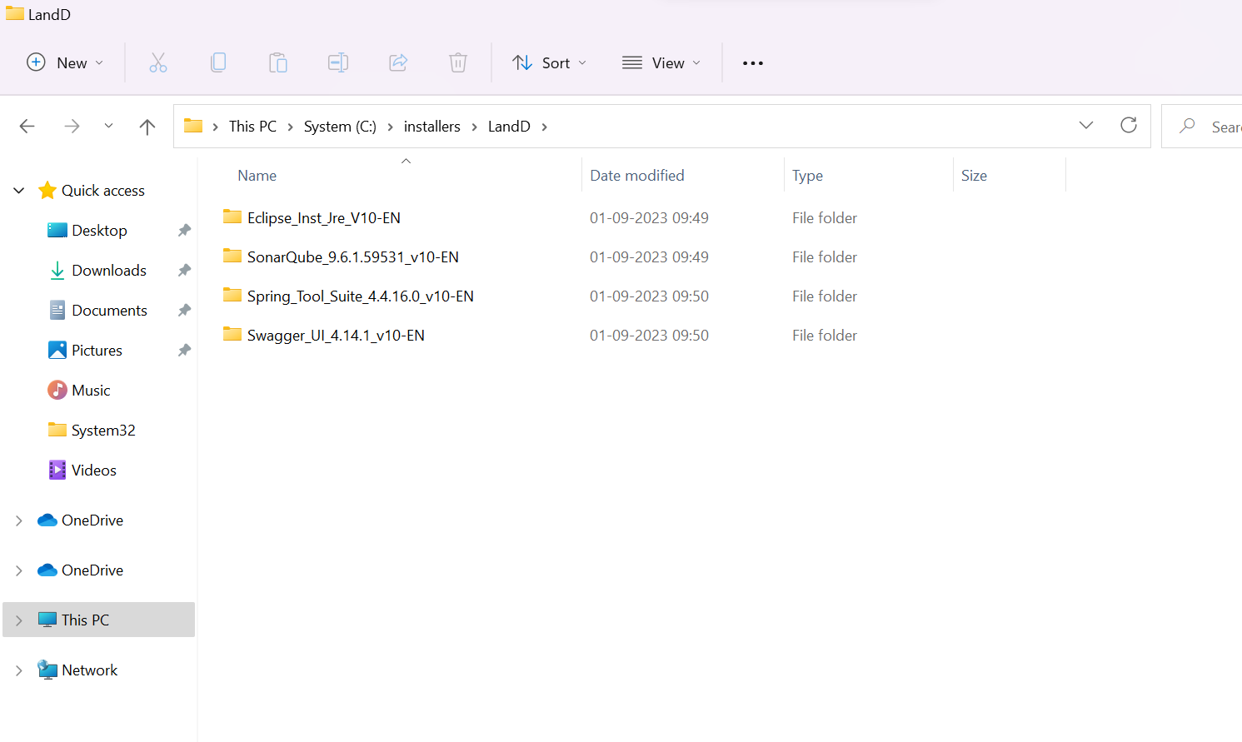

Right -Click on spring-tool-suite-4-4.16.0 > Show more options > 7-Zip > Extract to “spring-tool-suite-4.16.0

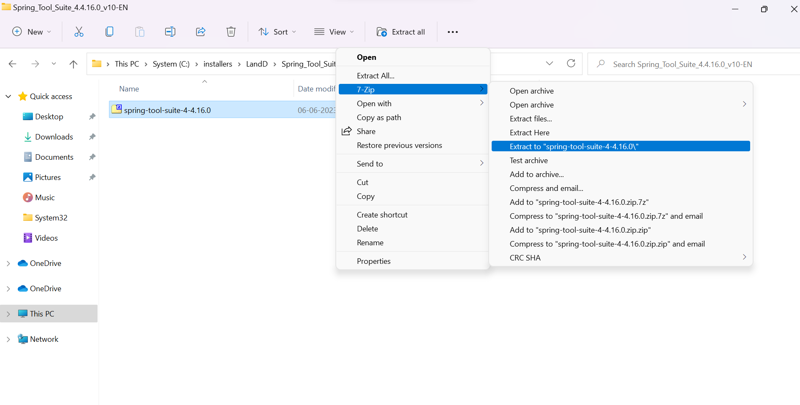

While extracting the Zip-File the below pop-up will appear

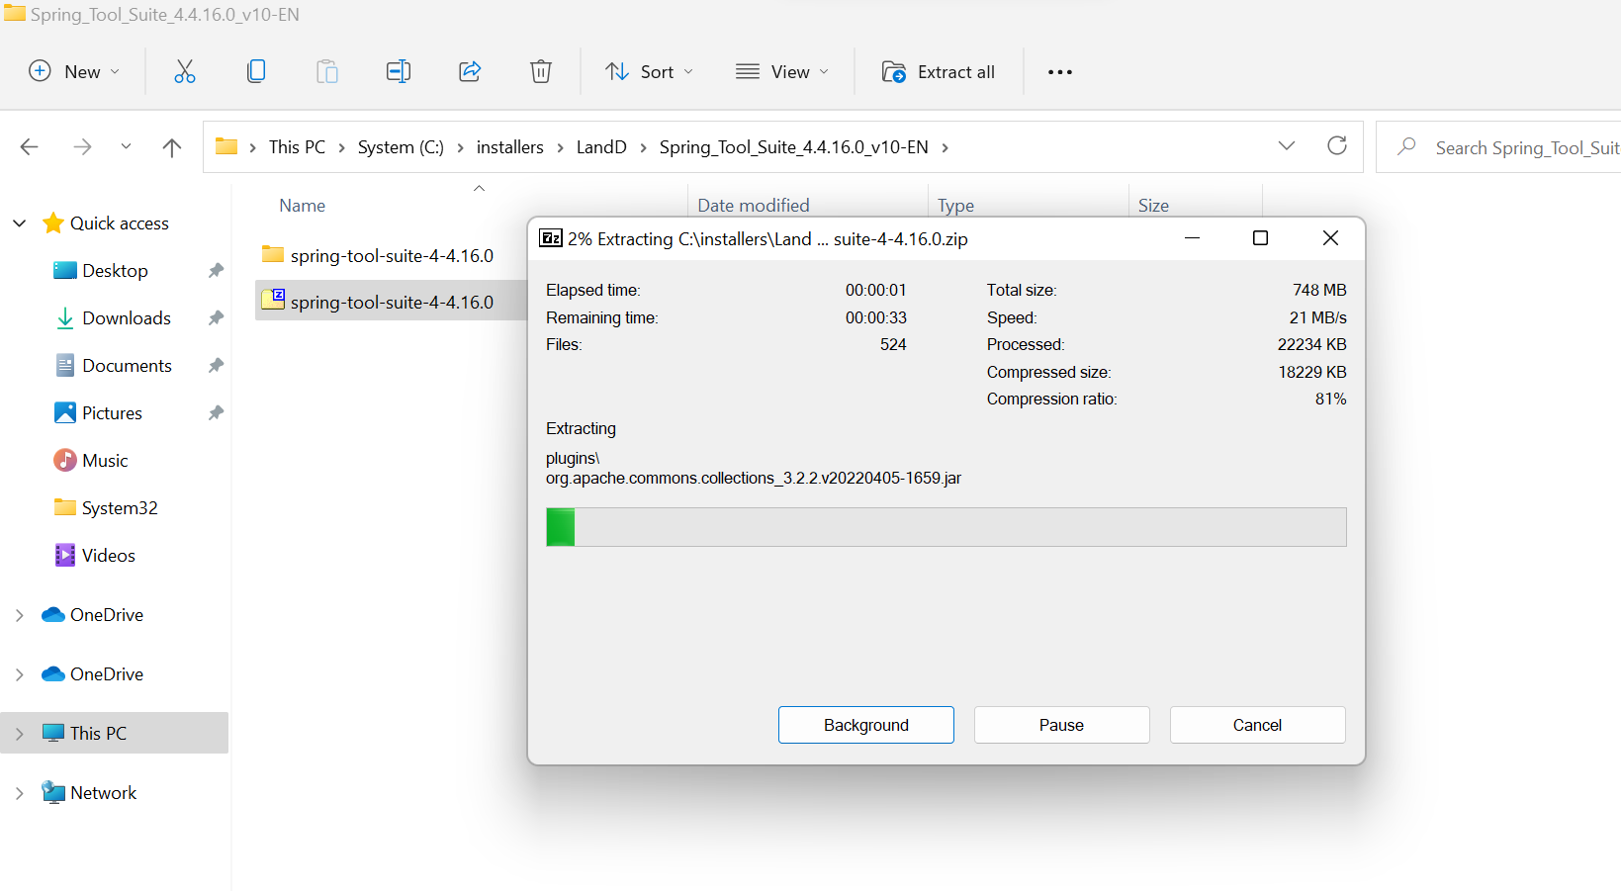

Click on spring-tool-suite-4.4.16.0 Folder

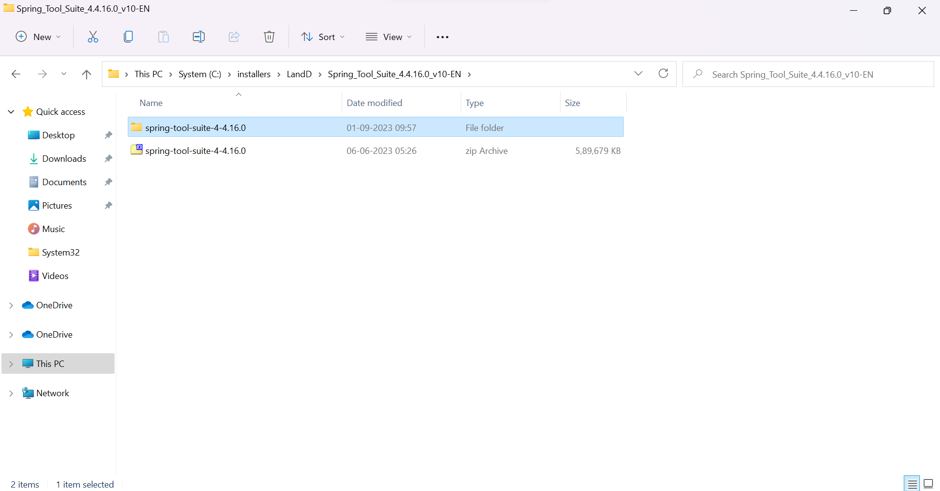

Click on SpringToolSuite4

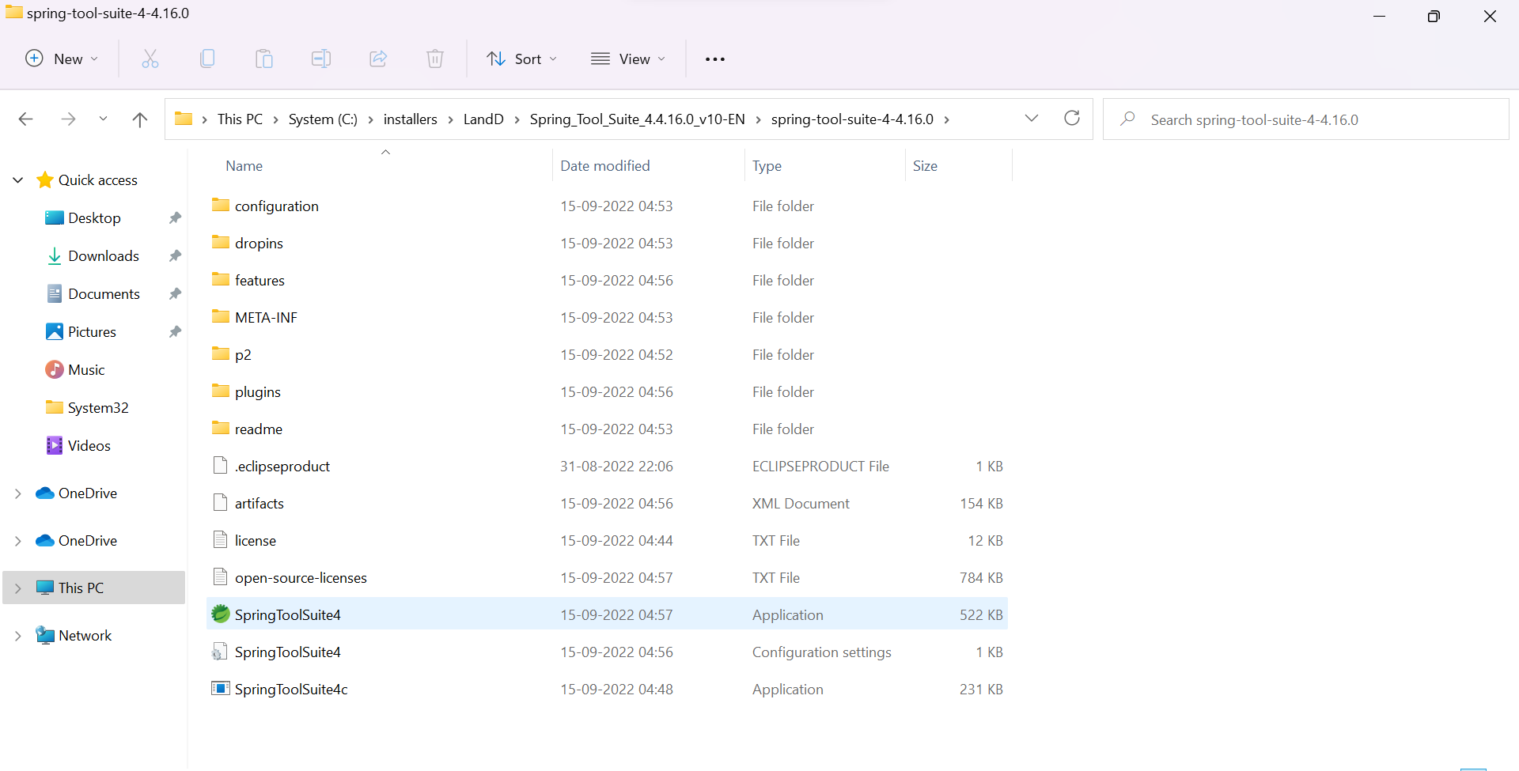

Click on Launch

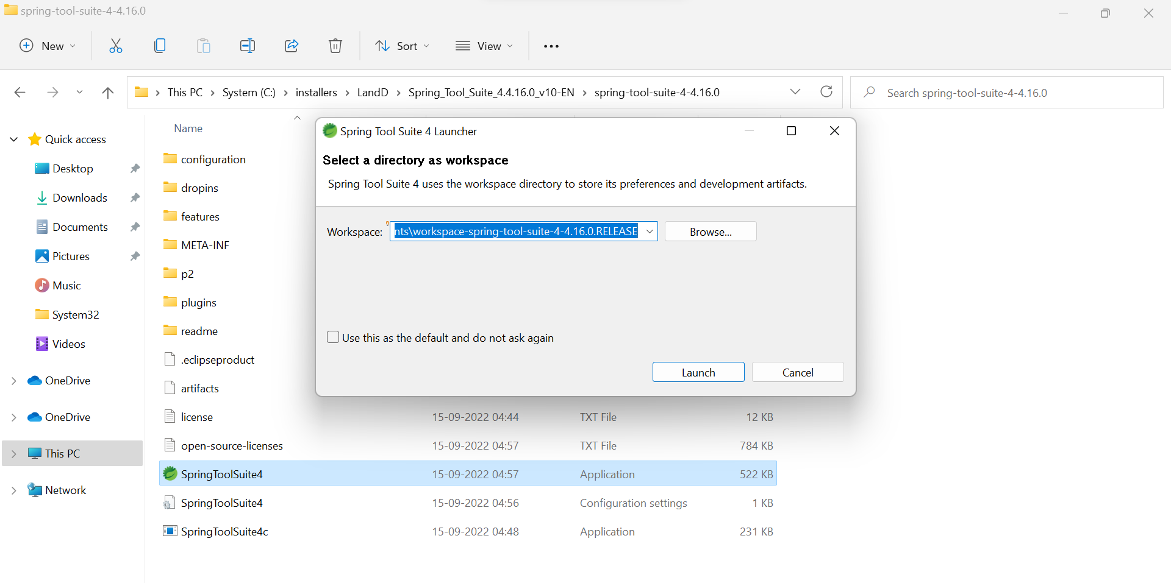

Below pop-up will appear once after Launch

